# Assignment 1

1- a) ===)

b) =

2- t1=

3- 2ms n=100

2=100 $\sqrt{100}*c$ c=0,002

n=2500 t=2500 $\sqrt{2500}$*0,002=250 ms

$\frac{250}{2}=125$

Running time will increase 125 times for size increasing 25 times.

$$\frac{25k\sqrt{25k}}{k\sqrt{k}}=\frac{125k\sqrt{k}}{k\sqrt{k}}=125$$

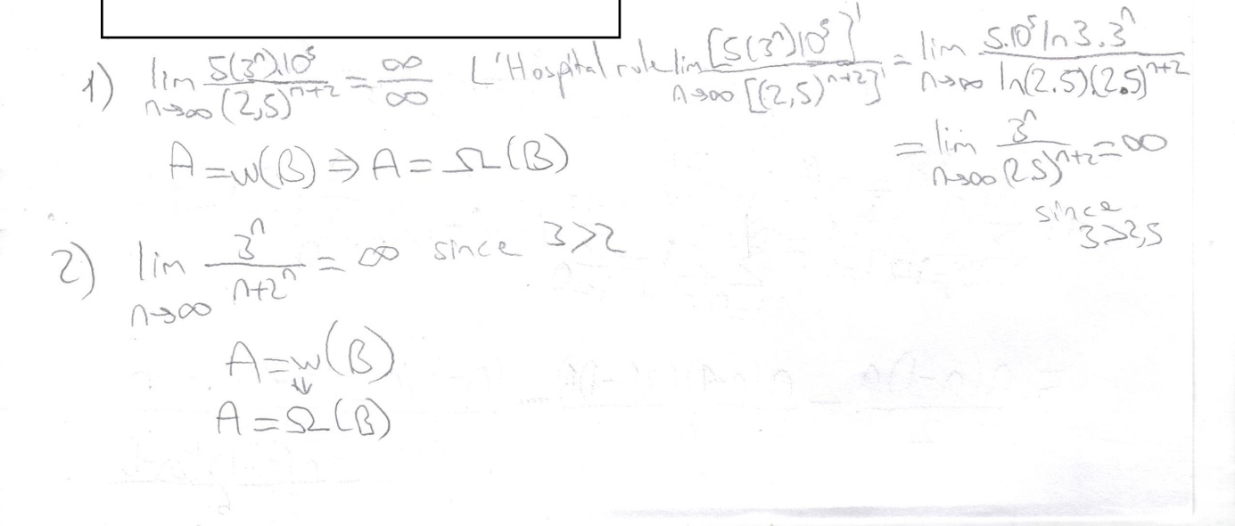4-

5-e) def foo2(n):

return (n*(n+1)/2)+(n*(n+1)*(2*n+1)/6)-n*n-n

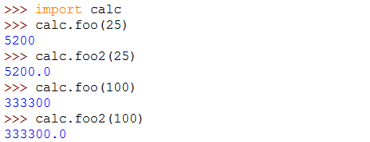

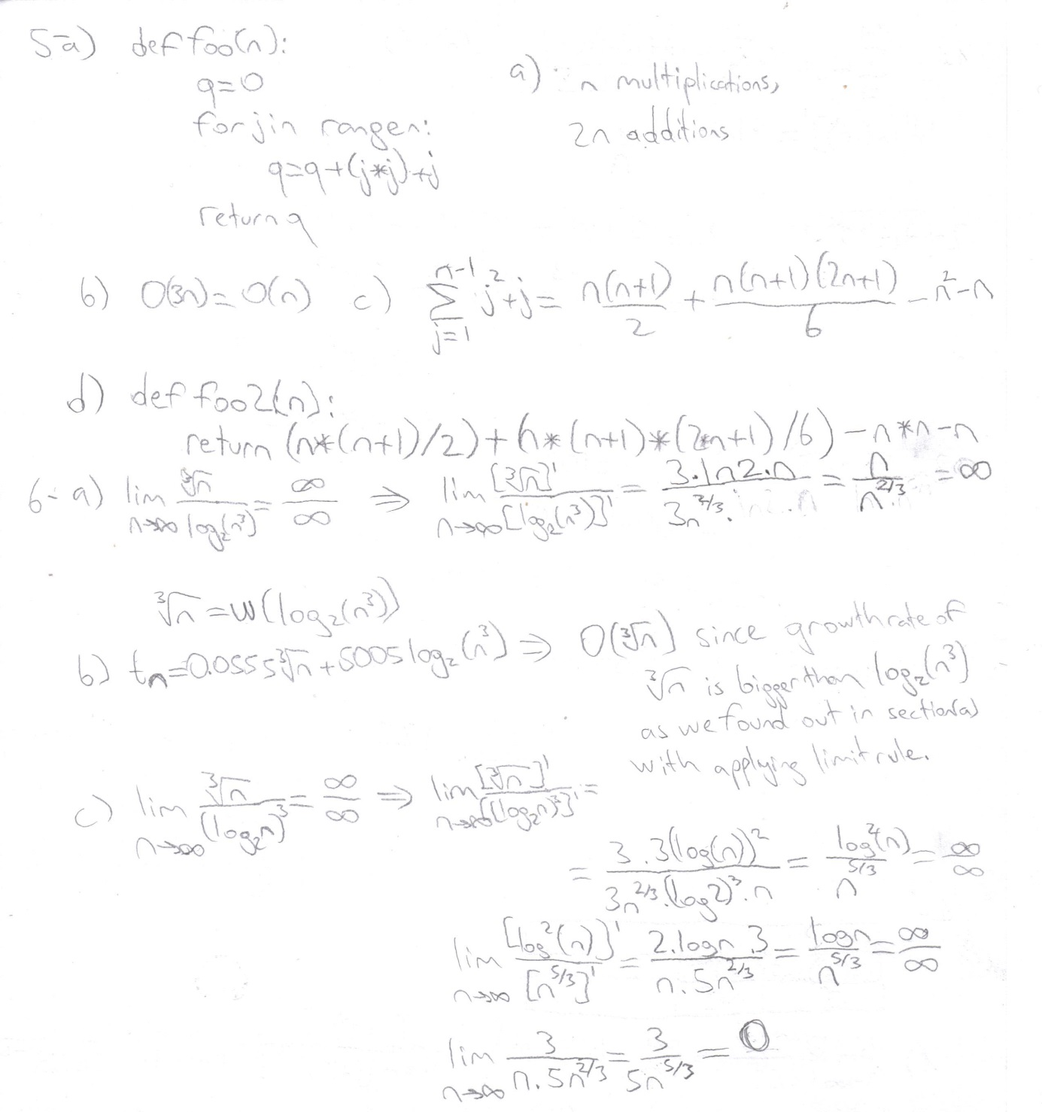

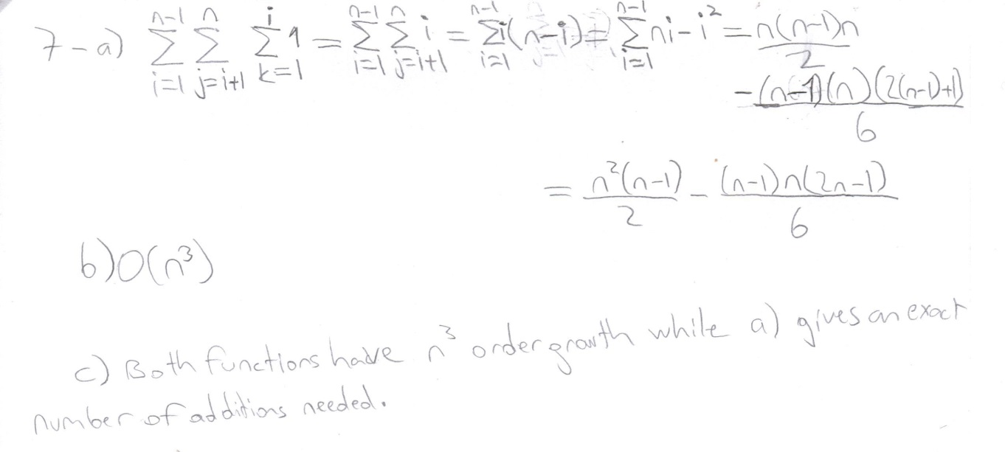

8- Since it is guaranteed that first element of the list repeated 1 time on the rest of the list first loop will only iterate once. Second loop runs from 2nd to nth element of the list chance of finding our element is same on every slot this is binomial distribution.

E= $\frac{1}{n-1}+\frac{2}{n-1}+\frac{3}{n-1}+…+\frac{n-2}{n-1}+\frac{n-1}{n-1}=\frac{n(n-1)}{2(n-1)}=\frac{n}{2}$

Therefore average number of comparisons we have to do is $\frac{n}{2}$. Which is O(n) time complexity